

Child poverty and neighbourhood
opportunity structures: managing on low income in Barcelona

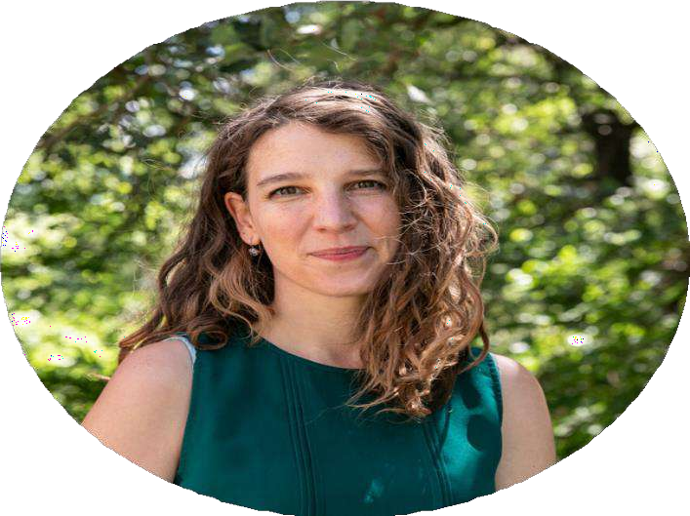
Alba Lanau
Universitat Pompeu Fabra


Thursday, 11th December
13.15h – 14.45h
Seminari A

F. de CCPP i Sociologia, UAB & Online
Registration:

LINK TO THE FORM

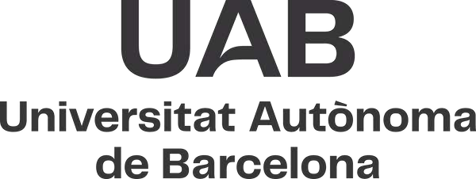


www.geps-uab.cat @gepsuab.bsky.social






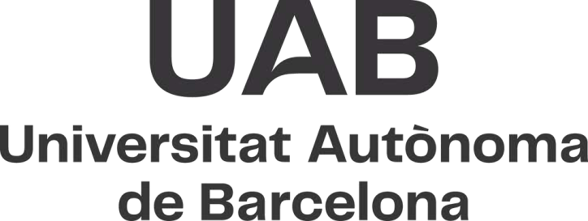


Child poverty and neighbourhood opportunity structures: managing on low income in Barcelona

Alba Lanau
Professora i investigadora Ramon y Cajal. Departament de Ciències Polítiques i Socials
Universitat Pompeu Fabra

DEC 11
13.15h - 14.45h

Seminari A
F. Sociologia,UAB

Registration
When faced with financial shocks, families often combine multiple resources, including savings, networks, public transfers and services, to cover their needs and respond to changing conditions.
This study explored the strategies families with children in Barcelona deploy to respond to financial shocks by analysing interviews with 29 families experiencing difficulties to make ends meet. Through the technique of event interviews, developed for the project, the data shows how and to what extent families’ strategies are shaped by their past trajectories and resources. By contrasting the experiences of families with diverse resources (both private and public), the study seeks to illuminate some of the mechanisms through which structural constraints shape coping strategies and thus, agency.
t
Understanding family strategies is particularly relevant in the current context framed by the aftermath of the COVID pandemic and the recent increases in energy, food and housing prices that affected the most disadvantaged.

www.geps-uab.cat @gepsuab.bsky.social

