Commitment Document and Code of Good Practice: Frequently Asked Questions (FAQs)
- Username and password
- Signing the Commitment Document and the Code of Good Practice
- Possible issues you may encounter

1. Username and password (credentials)
To access the Guest signature platform (doctoral students, thesis supervisors and tutors), please note that the username is your NIU number (never NIU@uab.cat) and the password (credentials).
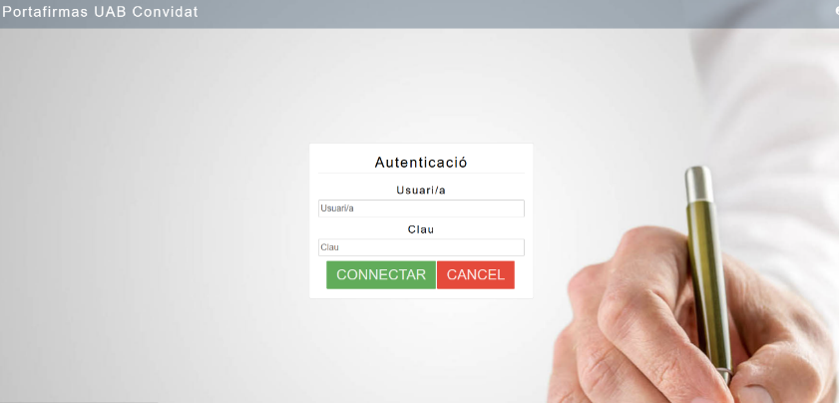
2. Signing the Commitment Document and the Code of Good Practice
- Please be aware that doctoral students and thesis supervisors will receive two emails to access the signature platform and sign the documents (you should check the subject line of the email). They will receive as many emails as new students they supervise or tutor.
- a) One to sign the Commitment Document:
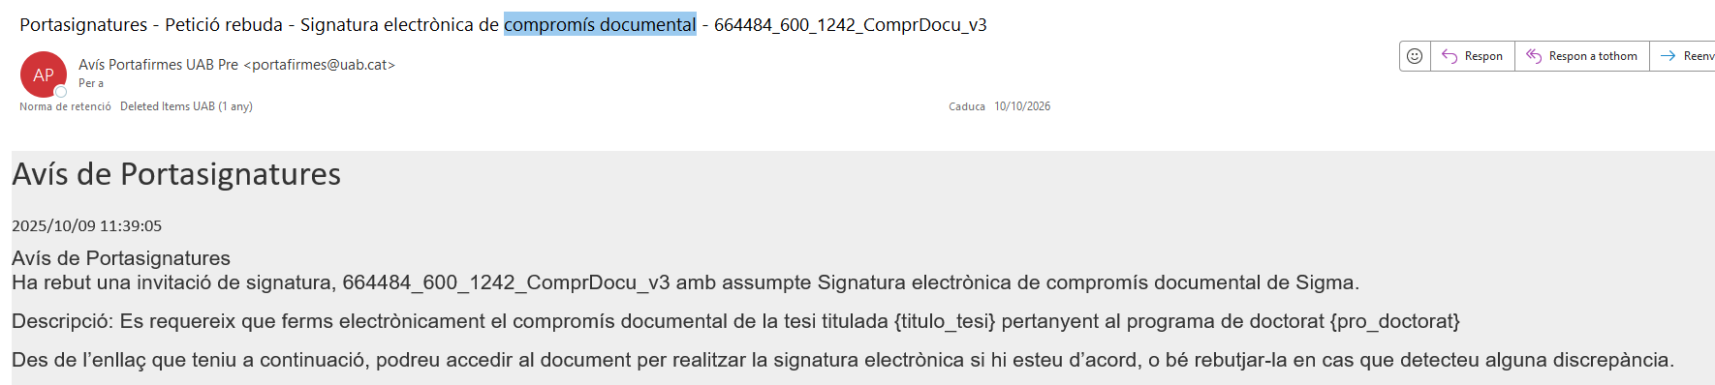

b) And another to sign the Code of Good Practice
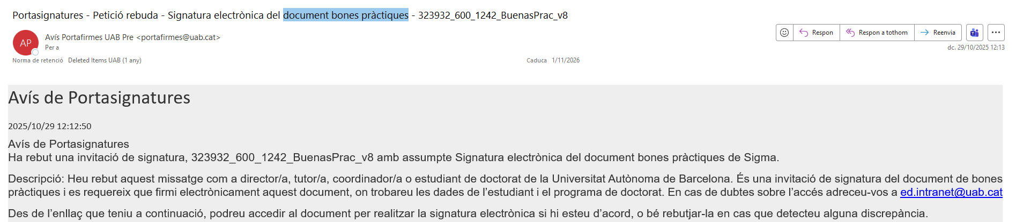
3. Possible issues you may encounter
Message: “Invalid credentials”
The simplest solution is to go to sia.uab.cat, access the Services section, click on “”, and then ... 
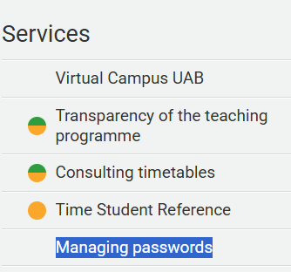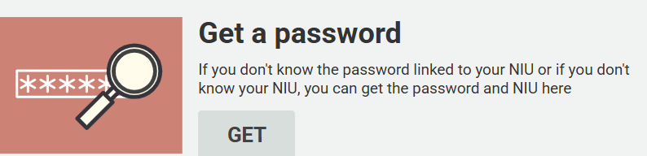
With this option, you will be prompted to set a new password, which will be updated across all applications (it performs a kind of “reset”).

Message: “This signature request has already been completed”
If this message appears, please write to: ed.intranet@uab.cat


