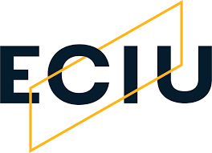 |  | Researchers Mobility Fund

UAB’s rules for participation
Aims:
- To promote interactions and strengthen research collaboration among researchers across all member institutions of the ECIU University.
- To catalyse international research excellence and improve high-quality research outputs within the ECIU university, for example through joint research funding applications, publications, and research projects.
- To support professional research career development through the acquisition of specific know-how from experience and good practice at another member institution.
- To provide access to the excellent research facilities at member institutions of the ECIU University.

‍Who can apply?
This call is addressed to PDI doctor with research duties.

Funding available
Applicants may apply for a grant of up to €5,000. Each ECIU University member institution allocates € 20,000 a year (2021, 2022 and 2023) for the Research Mobility Fund.

Research fields supported
The RMF is open to all disciplines, with preference given to applications addressing the common research fields in the framework of the UN Sustainable Development Goals 11 (Sustainable cities and communities)

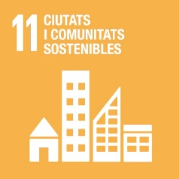

What can the funding be spent on?  The RMF in general is used for outgoing travel and associated subsistence costs for visits to member or associate member institutions of the ECIU University. The applicant remains an employee of the home institution, which is responsible for awarding grants to applicants from the same institution and paying the usual salaries in accordance with its own financial rules and regulations.  In principle, the funding covers following types of costs and expenditure:  - Travel costs (e.g., bus, train and flight tickets)  - Associated subsistence costs (e.g., accommodation and travel allowance).  If experiments are planned, the coverage of lab costs (including access) needs to be agreed between participating member institutions before the mobility.  In principle, the funding does not cover the following types of costs and expenditure:  - Conference or symposium attendance fees, or costs for consultancy work for research proposals.  - Bank fees charged by a hosting member institution.  - Participants’ personal expenses.  Duration of stay at a member institution  Applicants are obliged to undertake a minimum stay of 5 working days (excluding travel days). Duration of stay is negotiated on an individual basis which the destination institution. |  | ‍Insurance  It is the responsibility of the beneficiary to have medical coverage during their stay (European card, private insurance or other)  Evaluation of your applications  The decision to award an RMF grant is made by the member institution where the applicant is based. The criteria used to assess and select applications include the following:  - Purpose and clarity of outcomes from proposed collaboration are clearly articulated.  - Research goals behind the collaboration are clearly identified.  - Resulting research and/or knowledge exchange benefits to collaborating parties and universities are evident.  - Longer-term mechanisms for supporting collaboration beyond the ECIU fund are considered.  - In the event of a tie, priority will be given to applications aimed at the joint preparation of proposals for Horizon Europe or Erasmus + calls.  Documentation to be provided: a letter of acceptance from the host University must be attached to the application.  Next application collection date: October 15th, 2022
How to apply for  an RMF grant in UAB? |  | This application form must be completed no later than October 15th, 2022. Applications will be resolved by the Research, Transfer and Innovation Commission.
More information: ECIU Researchers Mobility Fund
Contact UAB: opi@uab.cat

