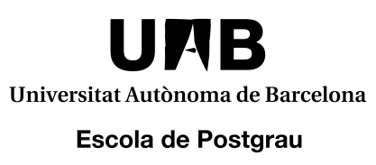

I, _________________________________________________________________________, holder of DNI/NIE/passport nº ___________________________________,

DECLARE:

That in the 20__/__ academic year I will apply for the Master degree in ____________________________________________________________ without submitting the required documentation, for the following reason:
I do not have the required documentation for access (university bachelor’s degree or equivalent) and I accept that I will not be admitted onto the programme until I present the certificate or official proof of having obtained it, before the beginning of the master’s degree, at the User Information Office of the Graduate School.

And in witness whereof I sign this declaration in Bellaterra on ____ ________________, 20____.

(Signature)

